The impact of economic sanctions on Russia's people

Research Question:
To what extent have the economic sanctions changed life in Russia?

Word count: 3970

Table of contents
- List of Abbreviations..............................................................................1
- Introduction............................................................................................2
- What is an Economic Sanction?...................................................2
- Why are the economic sanctions imposed?..................................3
- The war in Ukraine: “Reunification or Forced Assimilation?”....5
- Negative impacts of economic sanctions on Russia.............................10
- Positive impacts of economic sanctions on Russia..............................17
- Conclusion............................................................................................20
Abbreviations
OCSE — The Organisation for Security and Cooperation in Europe
OHCHR — Office of the High Commissioner for Human Rights
IOM — International Organisation for Migration
USD — United States Dollar
RUB — Russian Ruble
CAATSA — Countering America’s Adversaries Through Sanctions Act

Introduction
According to the Council on Foreign Relations, “Economic sanctions are defined as the withdrawal of customary trade and financial relations for foreign- and security-policy purposes.”, economic sanctions are financial and commercial penalties applied by one or more countries against a targeted country, group, or individual. Economic sanctions are imposed with the goal to achieve foreign policy objectives and prevent conflicts from arising. Sanctions are only forced upon the aggressor if they have violated perceived international norms. They can range from embargoes to more targeted restrictions, such as trade bans, asset freezes, and travel restrictions.
Joseph Nye, the former US Assistant Secretary of Defence for International Security Affairs who co-founded the theory of neoliberalism in international relations, once said that “Power is the ability to influence the behaviour of others to get the outcomes one wants.” For Joseph Nye, power did not mean using only force, but also meant using persuasion, incentives, and specific psychological methods to change the behaviour of opposing states. So, to divide power into different categories, Joseph Nye created a diagram that illustrates a spectrum ranging from "hard" to "soft" methods.
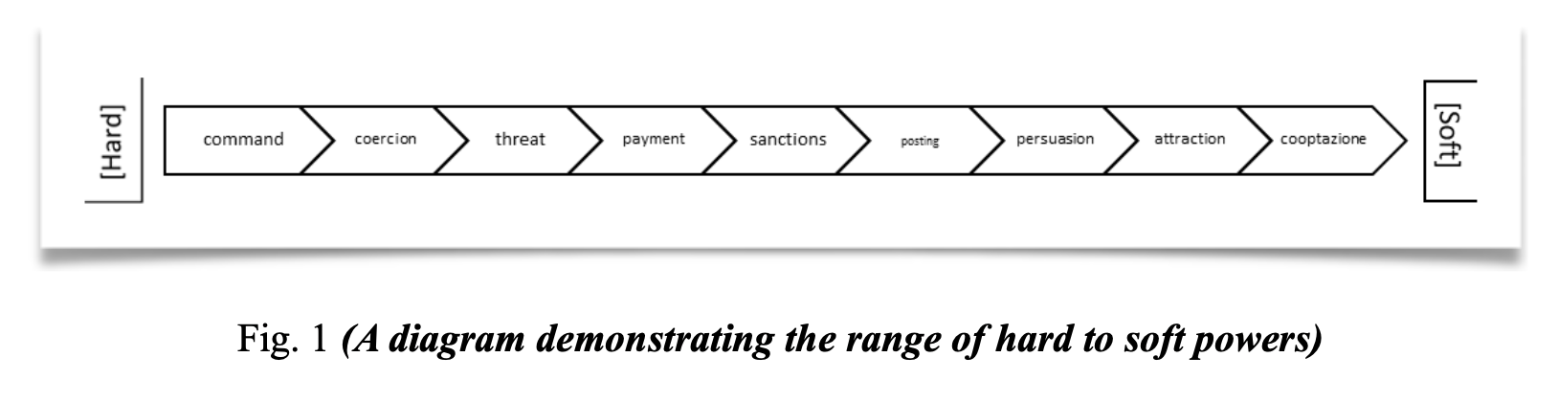
Fig. 1 (A diagram demonstrating the range from hard to soft powers)
Hard power can be considered as military force and threats to influence the behaviour of other states. Soft power, on the other hand, relies on attraction and persuasion, using culture and foreign policies. The middle of it, diplomacy, economic aid and the use of sanctions against Russia is an example of smart power aimed to put a stop to a conflict.
While sanctions have severely impacted the Russian economy, they have not yet achieved the intended political outcomes. The resilience of the Russian government and its continued military operations in Ukraine suggest that economic sanctions alone may not be sufficient enough to end the conflict. This report will be discussing how far has the west achieved in terms of bringing peace to Ukraine and how it has affected quality of life in Russia.
Why were these economic sanctions imposed?
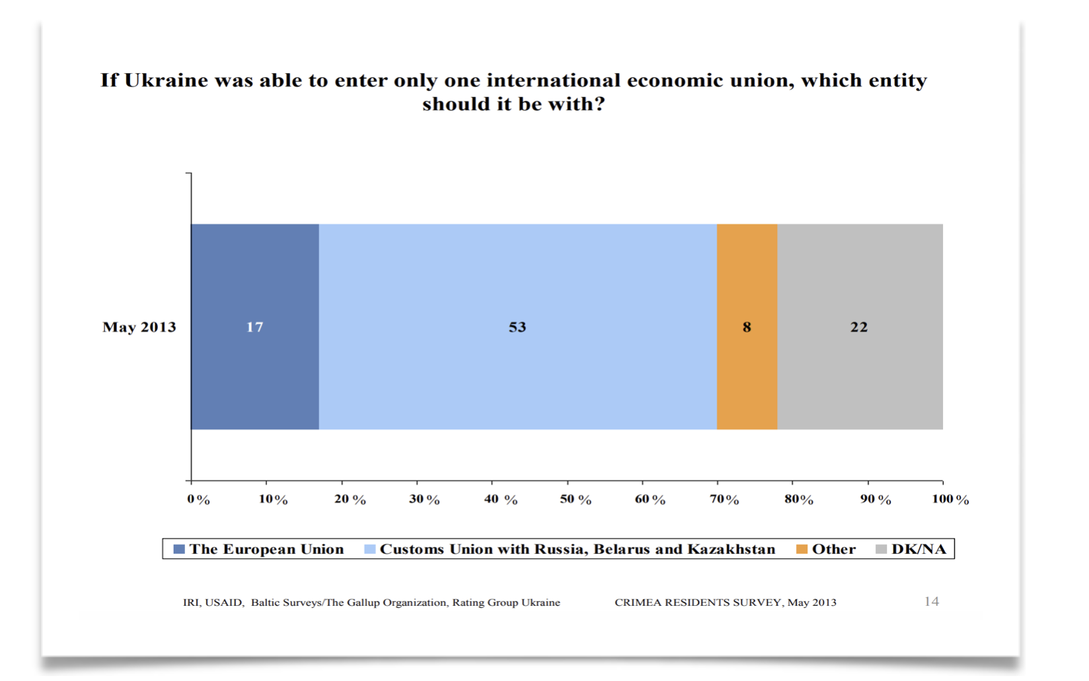
In November of 2013, President Yanukovych of Ukraine, rejected the EU trade pact, which caused the violent “The 2014 Euromaidan protests” by civilians inside the country. According to the House of Commons, “Toward the end of February 2014, unidentified military figures, later confirmed to be Russian personnel, surrounded the airports in Crimea, a majority Russian peninsula in Ukraine. The Crimean autonomous assembly was then seized by pro-Russian forces.” Airports located in Crimea (a predominantly Russian-populated peninsula in Ukraine), were circled by unidentified military individuals. These unidentified military individuals were later found out to be a part of the Russian military personnel. Then, pro-Russian forces took control of the Crimean autonomous assembly. In May of 2013, the
Fig 2. (Crimea Residents Survey, May 2013)
USAID conducted a survey on which economic union should Ukraine join. The results of the conducted survey given in Figure 1 show that 53% of respondents voted on joining an economic agreement with Russia, Belarus and Kazakhstan. However what should be taken into account is the percentage of ethnicities distributed in the Crimea Region. It is essential to consider the ethnic composition of the Crimean region to assess whether any biases may have influenced the situation. Because of this, USAID also surveyed the population on their ethnicity and the main language spoken at home. The results of the survey are demonstrated in a pie chart given in figure 3.

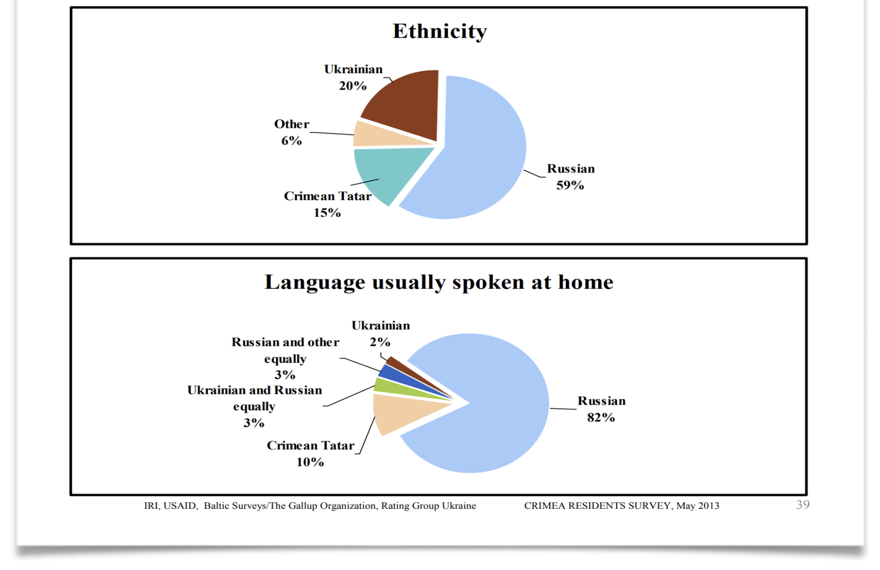
Fig 3. (Crimea Residents Survey, May 2013)
The percentages given exhibit the results of the Russian population and language being dominant in the Crimean region by 59% and 82% respectively.
To justify the annexation of Crimea, Russia held a referendum which refers to an election in which all the people in a specific area are deciding on an important political or social question, law or proposal by directly voting prior to the invasion. The ballot question, defined as the topic of the referendum, was whether Crimea should be a part of the Russian Federation. According to Russian officials, 95.5% of the voters wished to join Russia. Al Jazeera, a Qatari international news source had reported that this referendum was held by Pro-Russian separatists, which goes against Ukraine’s Constitution. As outlined in Article 73 of Ukraine’s Constitution “Issues of altering the territory of Ukraine are resolved exclusively by an All-Ukrainian referendum.” The referendum regarding the Crimean Peninsula was held by Russian officials, violating Ukraine’s constitution. The referendum was not internationally recognised and was considered to be “​​in violation of international law and in contempt of Russia’s commitments as an OSCE participating State” due to the bias coming from the Russian-conducted vote and majority of the population in Crimea being Russian. Even though the results of the referendum held were considered to be illegitimate, 4 months later, in March 2014, Russia began to take control of the Crimean Peninsula by annexing the area, justifying it with the flawed referendum. This eventually led to a full-scale military invasion in February 2022 which developed into the first full-scale war in the European continent after almost 75 years of peace since the end of World War 2.

As the Ukrainian war is considered to be one of the most significant conflicts of the 21st century as the human cost of the Ukraine war has been immense with 27,449 civilians dead from the Ukrainian side according to OHCHR. As of early 2023, the United Nations reported millions displaced both internally and externally. Because of this conflict a huge refugee crisis across Europe with 8.13 million Ukrainians crossing the border to Poland specified by IOM UN Migration since the start of the war. According to the United Nations High Commissioner for Refugees (UNHCR), one-quarter of Ukrainians are displaced either internally or externally. Cities like Mariupol and Bucha have now become cities with brutal warfare and mass graves.

The enforcement of the economic sanctions
The consequences of war in Ukraine has affected the country on a whole-scale, with normal life being disrupted. The conflict has not only caused immediate physical harm but has also led to long-term psychological trauma among survivors. Schools, hospitals, and residential areas have been bombed, leaving civilians without access to education, healthcare, and safe living conditions.
The EU, alongside its G7 partners and Australia, have imposed sanctions on the Russian government to limit its ability to pay for their war efforts. One of the EU’s biggest measures is the freezing €300 billion of the Russian Central Bank’s reserves, with two-thirds of this amount blocked within the EU. These reserves are money of Russian citizens, essential for stabilizing Russia’s economy, managing debts, and supporting the ruble, are now inaccessible. By that, Russian oligarchs, working class and the government had their significant portion of their financial assets stripped away from them. These sanctions aim to weaken the Russian Federation’s economic stability and reduce its strength to carry out military operations, intensifying the economic pressure on the country.
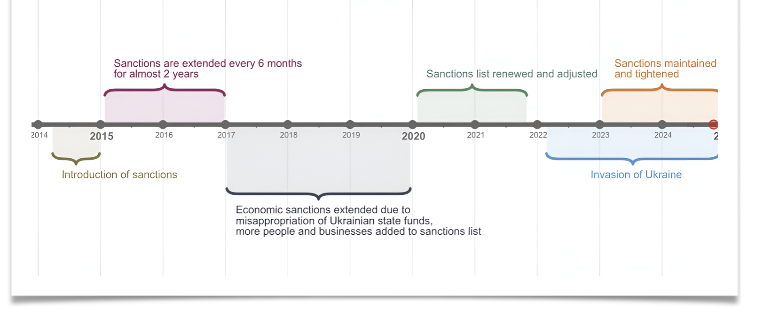
Additional penalties were imposed against the Russian Federation by the Obama administration in 2014. European Union’s governing body Consilium, has released a timeline, in which can be observed that economic sanctions imposed against Russia have evolved in the past decade:
Fig 4. (Chronological diagram of economic sanctions targeting Russia)
If looked into deeper, throughout March 2014, The EU imposes sanctions following Russia's annexation of Crimea, targeting individuals and business entities. This includes asset freezes and travel bans. The next month, additional sanctions are introduced, as the EU imposes more restrictive measures on Russian banks. In September of the same year, the EU expanded existing sanctions, including restrictions on state-owned enterprises and oil trade. 2015 January, the EU extends sanctions for six months which was a result of ongoing instability in Ukraine. 6 months later, in July sanctions were again extended due to the lack of progress in implementing the Minsk agreements that were supposed to stop the conflict. At the end of the year, sanctions were further extended, continuing to target various sectors.
In January of 2016, the sanctions were once again continued, the same happens for the rest of 2016. During the years of 2017-2019, the EU continued to renew sanctions regularly, as Russia was failing to make the Minsk agreements a reality. Additionally, in the year 2017, the United States of America passed a federal law of Countering America’s Adversaries Through Sanctions Act (CAATSA) and the main purpose for this legislation is to penalize Russia, Iran and North Korea for any aggressions they cause.
Throughout 2020-2021, the EU continued to renew and adjust sanctions which were an effect of the poisoning of Putin’s opposition leader, Alexei Navalny. Following Russia's full-scale invasion of Ukraine on February 24 of 2022, the EU added specific sanctions targeting the Russian economy, individuals, and business entities. These included:
- Restrictions on financial transactions
- Bans on exports to Russia of certain goods (luxury items and technology)
- Sanctions against high-profile Russian officials and oligarchs.
- A complete embargo on oil imports from Russia.
The next year, in 2023 the EU, maintaining strong solidarity with Ukraine continued to impose new sanctions while discussing strategies for long-term measures against Russia and how to not be dependent on Russian gas and oil exports. In the middle of 2024, the EU introduced the 14th package of sanctions, with anti-circumvention being a measure taken into account. This limits Russian individuals, groups and entities from accessing digital content by the use of hacking, VPN and software cracking tools.
While all these sanctions are meant to pressure the Russian government to at least decrease or stop the invasion into Ukraine, they have also caused a lot of problems for regular innocent citizens of Russia. However, at the same time, some people think these tough times have actually pushed Russians to become more independent and creative. So, an analysis of the disadvantages and potential advantages of these sanctions for Russian citizens is essential to understand their social, political and economical impact.
The negative effects of the economic sanctions
Economic sanctions are imposed to stop or change the way a state is acting, so usually, they damage the country. There are many disadvantages of economic sanctions such as:
- Harm to ordinary citizens
- Economic recession/devaluation of the currency
- Black markets
- Humanitarian aid challenges
- Limited effectiveness
- Increased social unrest
- Decline in living standards
- Loss of employment opportunities
- Decreased foreign investment
- The departure of some foreign businesses
A deep analysis of the consequences (listed above) faced by Russia after the implementation of economic sanctions will be conducted. This examination will focus on the immediate and long-term impacts on various sectors within the Russian Federation.
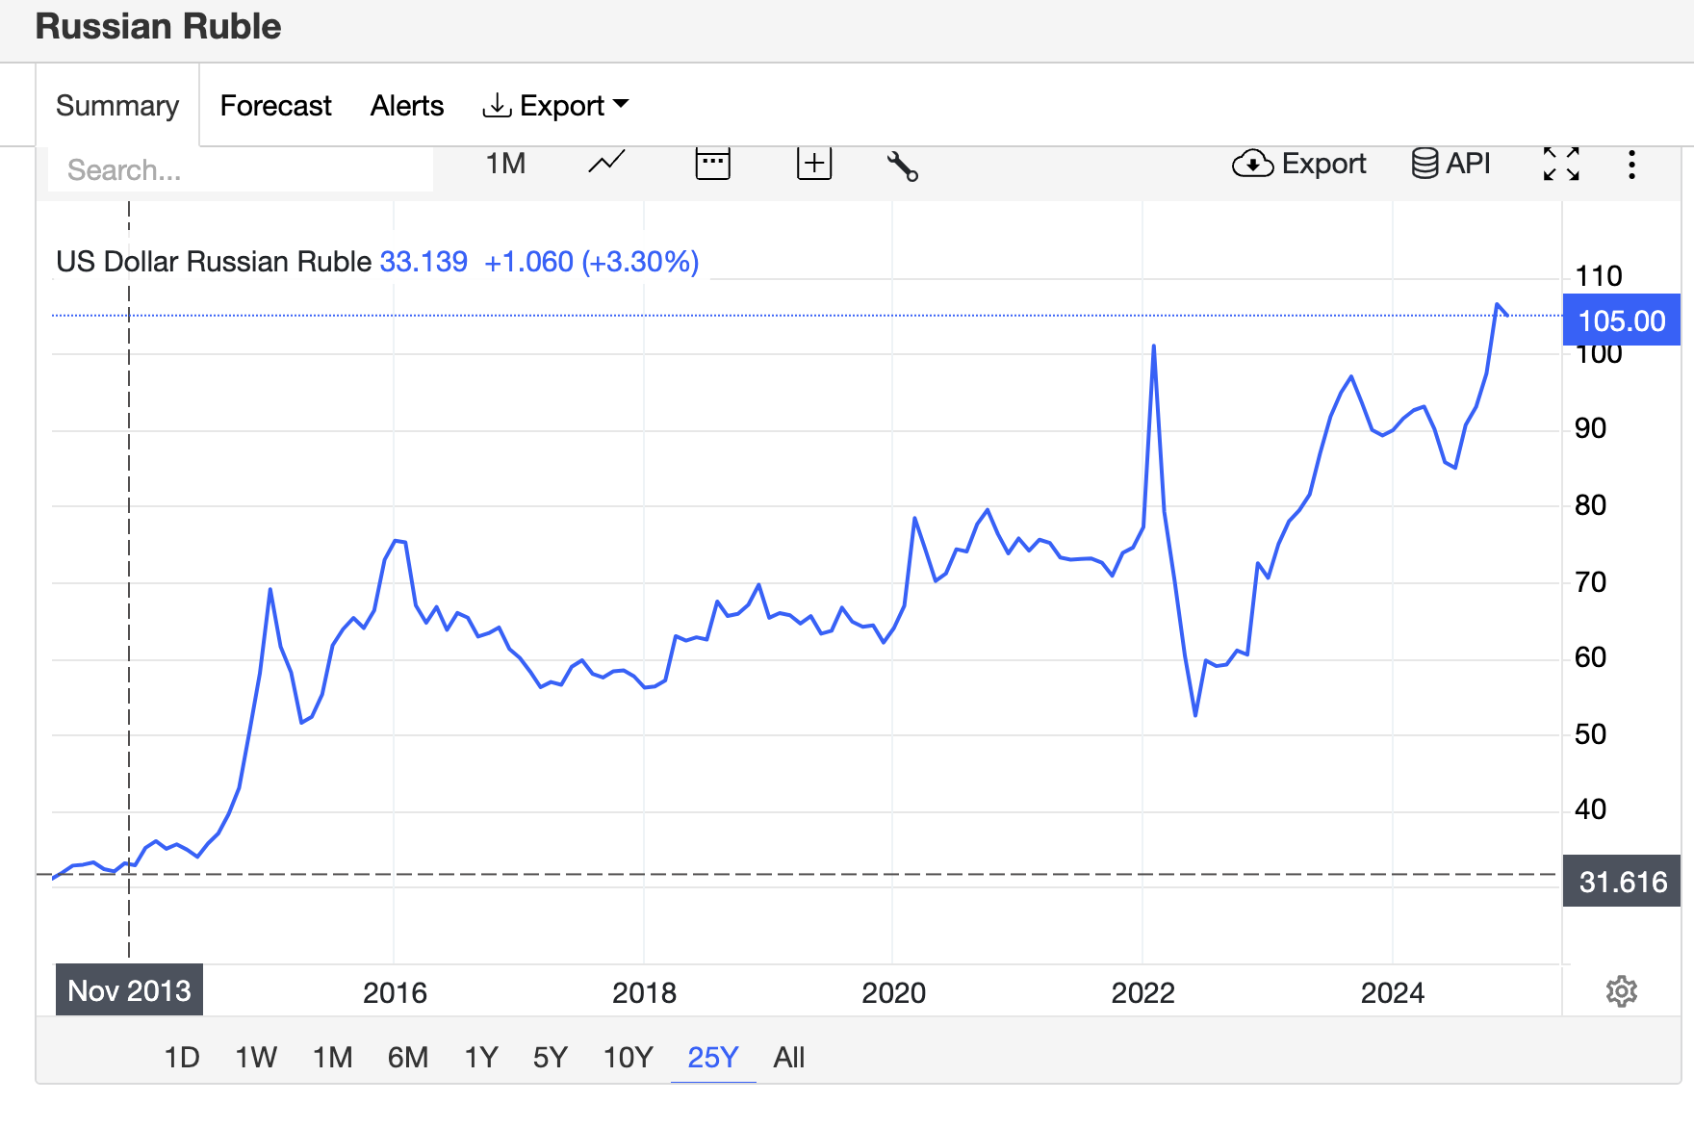
First of all, economic sanctions can lead to currency devaluation by limiting access to foreign exchange, reducing foreign investors’ confidence, and inflation within a country. The extent of devaluation depends on the country’s economic context and the government’s response to the sanctions.
Fig. 4 (A line graph illustrating the USD/RUB exchange rate trend from 2013 to 2024)
As seen in the line graph drawn in Figure 4, the depreciation of the Russian Ruble has been significant, with the value of the currency dropping by almost four times. Additionally, based on the research collected from Exchange Rates Org., a table has been designed with data for USD/RUB for each December starting from 2013, spanning over 10 years.
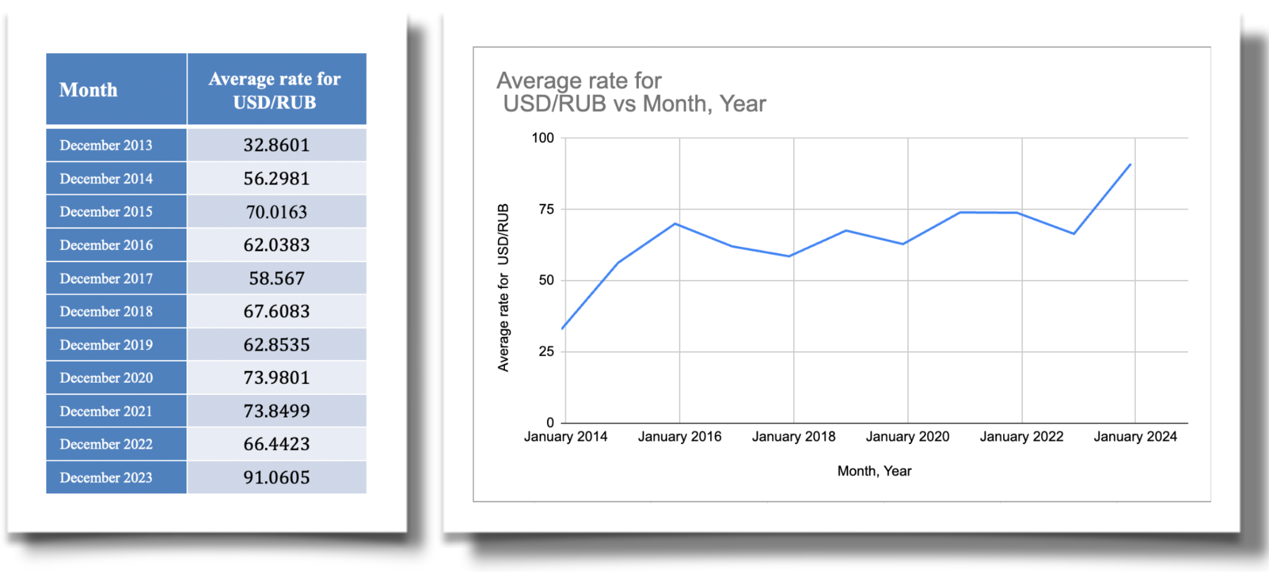
Fig. 5 (Table of USD/RUB) Fig. 6 (The table in fig. 5 converted into a line graph)
A more thorough analysis of Figure 5 and 6 reveal that in December of 2013, 1 USD equaled 32.8601 RUB. In December 2014, 1 USD equaled 56.2981 Ruble. The Russian Ruble’s value was fluctuating, till 2018. The range of 60-75 RUB per USD was kept until 2020, influenced by oil price fluctuations and economic sanctions. There was a relatively stable period, although there were fluctuations due to global events, such as the COVID-19 pandemic, which affected economies worldwide. In January of 2022, a sharp increase is observed, particularly towards 2024, because of different countries pressurising Russia.
This decade of the Russian Ruble constantly losing its value had its own widespread negative impacts across various sectors. One of these sectors that suffered from inflation could be the automobile industry. According to Eurasian Research, “In the following years due to a sharp depreciation of ruble, the costs of the cars during 2014-2016 years has increased 40% causing a 30% decrease in sales in 2015.” Typically, as outlined in Investopedia, the law of supply is when the demand for a specific product increases, the price of that product tends to rise as well because the relation between these two are directly proportional. However rising car prices and declining sales is an example of an indirectly proportional correlation and it is a very unusual trend activity which indicates a cycle of economic instability. The 40% price increase during 2014-2016, caused by the depreciation of the Ruble, made cars less affordable for consumers. This led to a 30% drop in sales in 2015, reflecting a lower customer interest, which means that the sanctions have impacted the citizens who had the means of purchasing from the automobile market.
Just like the automobile industry, the oil and gas sector also suffered from losses. According to “Ukrainska Pravda”, an Ukrainian online newspaper, “At least three Russian oil refineries have been forced to stop refining or cut production due to significant losses amid export restrictions, rising oil prices and high loan costs.” This excerpt mentions how the Russian oil refineries are cutting production due to a combination of export restrictions, rising oil prices, and high loan costs which are all a result of economic penalties imposed against the government. Refineries, based on Investopedia, oil refineries are plants/factories where crude oil is initially processed and later converted into a range of usable petroleum products, which include:
- Diesel
- Gasoline
- Heating fuels (kerosene)
Because of sanctions, Russian oil companies have reduced access to European markets, forcing Russia to sell oil at discounted prices to other countries, which lowers the profits they get from sales. High crude oil prices increase operational costs, while limited access to affordable loans makes it harder for refineries to maintain operations or invest in improvements. These factors together strain Russia’s refining capacity, threatening long term economic instability in the sector.
What’s more is that Anton Siluanov, Russia's finance minister had mentioned in his speech that “We will lose around $40 billion a year because of sanctions, and around $90-100 billion a year, if we assume a 30% drop in the price of oil.” Because Russian oil is no longer wanted by Western states, there is less demand which means Russia’s non-renewable resources’ prices will experience significant decreases as less companies/people/governments are buying it. Additionally sanctions are predicted to cause damages of almost 40 billion dollars annually. Many business analysts have predicted that “Each $1 fall in the oil price lops around $3 billion off export earnings. The oil price has slumped from nearly $115 per barrel in June to around $80 now.” Considering that the ⅔ of Russia’s global exports are oil and gas, there are huge potentials for serious profit loss, which also means that the oil sector has to fire many workers, indirectly contributing to unemployment.
Secondly, the banking sector has experienced issues because of monetary sanctions imposed. According to Carnegie Politika, a news source that specialises and focuses on conflicts and events concerning regions of Russia, Ukraine and Eurasia stated that
“Criticism has been raining down ever since the central bank raised interest rates to 21 percent in October as a result of high inflation. With the Russian economy overheated, further hikes are likely: annual inflation is currently approaching 8.7 percent; Russia has said it will spend an extra 1.4 trillion rubles ($13.9 billion) before the end of the year; labor shortages are acute; and salaries are growing.”
What can be taken from this information is that the annual inflation has risen to 8.7%, which leads the citizens of the Russian Federation to observe rising costs for goods and services, which limits people from purchasing what they want and ends up straining household budgets. Along with that, another information that the source suggests is that the combination of high rates of inflation, high wages, labor shortages, increased government spending, and raised interest rates indicate that the Russian economy is suffering from critical problems due to the economic sanctions. The raise of interest rates was introduced in 2014, called the “2014 Rate Hike”, when interest rates increased up to 17% as a result of depreciation for the Russian Ruble since the introduction of economic sanctions. The second raise was by 3% in 2022, as the full-scale invasion of Ukraine started to take place. Even though rate cuts were introduced 3 months later, with the interest rates dropping to 16% in the beginnings of 2024, they soon rose up to 21%. Carnegie Politika assumes that these interest rates of 21% will remain for a while. The purpose of keeping the high interest rates at a fixed intensity is to get the inflation back to its normal level. A weaker ruble which is a result of economic embargoes and that worsens inflation by raising the cost of imports in Russian currency. This is obvious that the prices consumers have to pay become higher than usual. To change this, The Central Bank of Russia is raising interest rates, making borrowing more expensive, which is supposed to reduce domestic demand for goods, including imports, and help control inflation. However, instead of fixing the issue, it causes more problems as the constant rate of higher interest rates from Russian banks also means that borrowing money becomes more expensive for businesses and individuals, which can slow economic growth, discourage investment and create more unpayable loans for the population.
The positive effects of the economic sanctions
Economic sanctions have inadvertently caused the emergence of black markets. When official economic channels are restricted, individuals and companies often choose the illegal markets to bypass sanctions and sell their products. In Russia’s case, due to oil bans and economic penalties, the access foreign currency and the devaluation of the Russian Ruble has been hard. The creativity of business entities and people of Russia has encouraged them to join into black market activities to meet the demand for imported goods and restricted technologies that the customers want. These markets have lowered the effectiveness of the sanctions imposed. According to Harvard International Review, (HIR) “In November 2023, The Washington Post found that petroleum products that had originated in Russia were still flowing to the Motor Oil Hellas refinery in Greece. Rather than traveling directly to Greece, the oil was routed through facilities in Türkiye to hide its Russian origins. The tankers, departing from ports on the Black Sea, travel through the Bosporus Strait to the Dörtyol shipping terminal in Türkiye. From there, the oil is shipped to Greece, where it is mixed into the supply purchased by the US military. Of the 5.4 million barrels of fuel oil recorded in the Dörtyol shipping terminal, all but 1.9 million were discovered to have originated from Russia. Strikingly, it is the US Pentagon buying Russian oil to fuel its ships and planes.” The HIR states that in November 2023, The Washington Post revealed that Russian-origin petroleum products were still reaching the Motor Oil Hellas refinery in Greece, despite the EU, which Greece is a part of, had imposed sanctions against Russia’s oil. To hide their origin, the oil was routed through Türkiye instead of being shipped directly. Tankers departing from Black Sea ports passed through the Bosporus Strait to Türkiye’s Dörtyol shipping terminal, where the oil was then transported to Greece and mixed into supplies purchased by the U.S. military. Of the 5.4 million barrels of fuel oil recorded at the Dörtyol terminal, only 1.9 million were found to originate from non-Russian sources, which is a small percentage. Notably, the U.S. The Pentagon, the headquarters (HQs) of the United States Department of Defense, the same HQ that recently announced to aid Ukraine with 1 billion dollars as a part of long-term help, was discovered to be using Russian oil to power its ships and aircraft. Thus, while financial sanctions aim to apply pressure to Russian products, they can also “accidentally” end up being sold by trade networks to the same countries that are against the Russian government in the Ukrainian conflict.
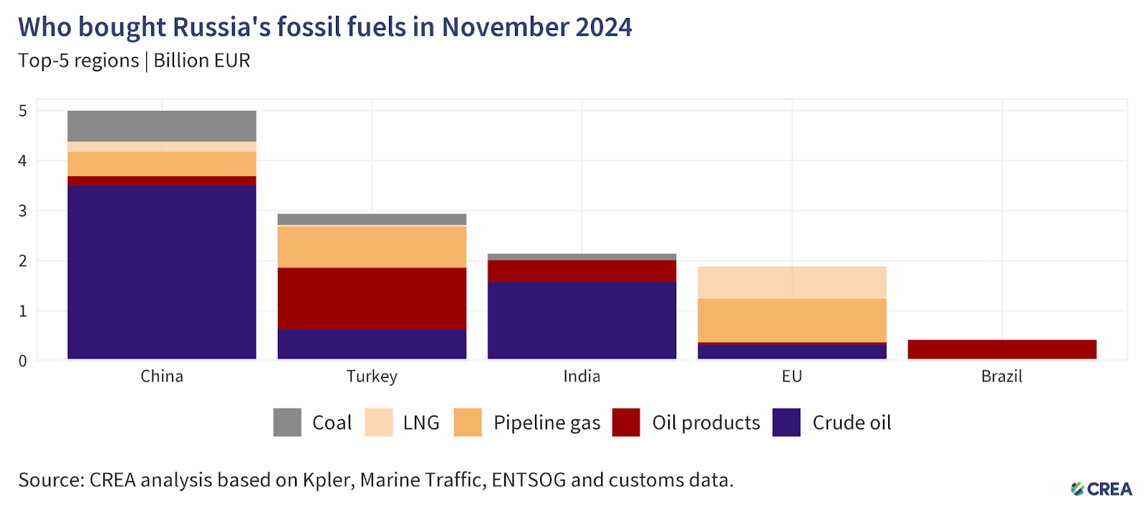
Furthermore, limits by the EU have opened up and strengthened trade relations for Russia with countries such as China, India, Brazil and Turkey.
Fig. 7 (A bar graph showing sales of natural resources of Russia)
As seen in the graph above, the BRICs group (consisting of Brazil, Russia, India, China) and Turkey have made purchases from Russia.
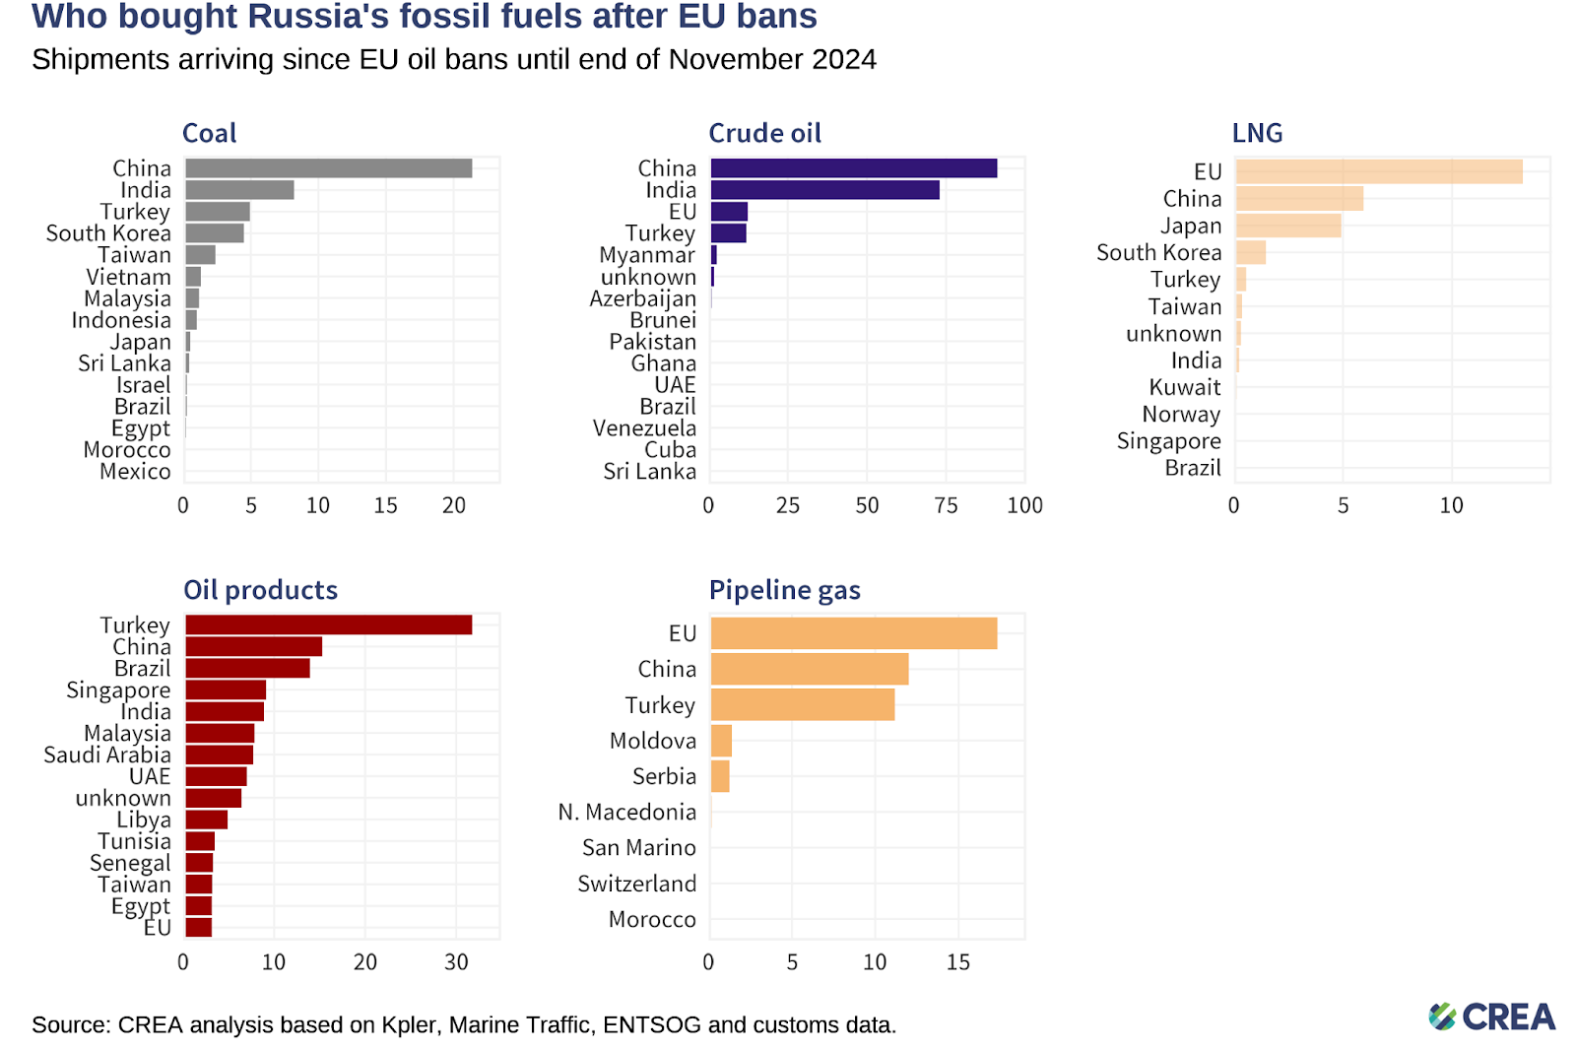
Fig. 8 (5 bar graphs illustrating the sales of different Russia’s natural sources)
From the numbers given in figure 8, it can be confidently concluded that Russia's energy exports have been shifted towardsAsian markets, particularly China and India as a result of Western sanctions continuing to restrict trade between Russia and Europe. In coal exports, China buys almost 46% of total exports. India follows with 17% by buying discounted Russian coal to support its growing energy demands thanks to their huge population. This shows their close economic ties with Russia for both countries. Turkey, even though accounting for only 11% is a crucial customer as they also export the Russian non-renewable resources worldwide. Similarly with crude oil, China and India together make up a huge percentage of 84% of Russian exports, purchasing 47% and India 37% respectively.
While Asian countries take the lead in coal and crude oil purchases, Europe’s reliance on Russia for other energy forms is still visible from figure 8. The EU remains the largest buyer of Russia’s liquefied natural gas (LNG), accounting for 48% of exports, and still imports 40% of Russia’s pipeline gas. These trends demonstrate Russia’s strategic turn of energy trade towards non-Western markets, with countries like China, India, and Turkey, helping Russia’s economy survive. This independence from Western countries also shows that Russia is far better without US and European governments money thanks to the strengthened economic bonds between Asian nations and Russia.
Conclusion
To conclude, economic sanctions have indeed had a huge impact on Russia’s economy. With Western countries observing the Ukrainian war unfold, more sanctions are imposed with the aim to create fluctuations in Russia’s economy. The sanctions are added with packages, targeting key sectors, such as banking, energy, and defense, and included asset freezes, trade restrictions, and prohibitions on luxury goods. The Russian ruble experienced a significant depreciation, which led to inflation, ultimately causing higher costs for everyday goods, and a decline in living standards for many citizens. Industries such as automobiles and oil refineries suffered from increased production costs and limited access to foreign markets. While these sanctions were designed to pressure the Russian government and reduce its capacity to wage war, they have also created economic instability, job losses, and social unrest for ordinary Russians. What’s more is that Russia’s Central Bank raising interest rates to quiet down inflation has further damaged the economy, making borrowing more expensive for both businesses and individuals. In a different perspective, western sanctions have significantly changed how Russia used to export energy. The sanctions have made Russia friendlier with non-Western countries, exposing the limitations of economic penalties. The recent shift toward Asian markets, particularly China and India, reflects Russia’s survival and adaptation skills to its current situation. The western world still depends on Russian LNG and pipeline gas, demonstrating how countries have their own interdependencies. To achieve peace in Ukraine, is to be able to effectively stop Russia from assaulting the Crimea region. This can only be achieved if the whole world agrees on cutting off Russia economically and politically, stripping them away from alternatives.

Bibliography
Al Jazeera. “Understanding Russia’s Referendums in Ukraine.” Al Jazeera, 23 Sept. 2022, www.aljazeera.com/news/2022/9/20/russia-unfolds-annexation-plan-for-ukraine.
Alexandra Prokopenko. “Russia’s Economic Woes Fuel Search for Scapegoat.” Carnegie Endowment for International Peace, carnegieendowment.org/russia-eurasia/politika/2024/11/russia-central-bank-dilemma?lang=en.
Artemchuk, Oleksii. “Russian Oil Refineries Cut Production Due to Significant Losses; Closures Possible – Reuters.” Ukrainska Pravda, 15 Nov. 2024, www.pravda.com.ua/eng/news/2024/11/15/7484697.
“Countering America’s Adversaries Through Sanctions Act-Related Sanctions | Office of Foreign Assets Control.” Office of Foreign Assets Control | U.S. Department of the Treasury, 18 July 2024, ofac.treasury.gov/sanctions-programs-and-country-information/countering-americas-adversaries-through-sanctions-act-related-sanctions.
Consilium. “EU sanctions against Russia.” https://www.consilium.europa.eu/en/policies/sanctions-against-russia/.
“Impact of Sanctions on the Russian Economy.” Consilium, www.consilium.europa.eu/en/infographics/impact-sanctions-russian-economy.
“Sanctions Adopted Following Russia’s Military Aggression Against Ukraine.” Finance, finance.ec.europa.eu/eu-and-world/sanctions-restrictive-measures/sanctions-adopted-following-russias-military-aggression-against-ukraine_en.
“Sanctions Tracker: EU’s 14th Sanctions Package Focuses on Anti-circumvention and Further Expands Sectorial Measures.” Herbert Smith Freehills | Global Law Firm, www.herbertsmithfreehills.com/notes/sanctions/2024-07/Sanctions-Tracker–EU-S-14TH-Sanctions-Package-Focuses-on-Anti-Circumvention-and-Further-Expands-Sectorial-Measures.
Hayes, Adam. “What Is an Oil Refinery? What They Do, Services and How They Work.” Investopedia, 30 June 2022, www.investopedia.com/terms/o/oil-refinery.asp.
Liu, Joie. “The Black Gold of the Black Market: Russia’s Lucrative (and Illegal) Oil Trades.” Harvard International Review, 28 Aug. 2024, hir.harvard.edu/the-black-gold-of-the-black-market-russias-lucrative-and-illegal-oil-trades.
McHUGH, David. “Russia’s Ruble Has Tumbled. What Does It Mean for the Wartime Economy?” AP News, 31 Aug. 2023, apnews.com/article/why-is-ruble-falling-ee777eeaf897d42befae052336fc35d5.
Nye, Joseph. Smart Power. Public Affairs, p. 26.
Public Opinion Survey Residents of the Autonomous Republic of Crimea May 16 – 30, 2013, USAID, pdf.usaid.gov/pdf_docs/pnaec705.pdf.
“Russia Puts Losses From Sanctions, Cheaper Oil at up to $140b a Year.” Jordan Times, 24 Nov. 2014, jordantimes.com/news/business/russia-puts-losses-sanctions-cheaper-oil-140b-year.
Raghunandan, Vaibhav. “November 2024 — Monthly Analysis of Russian Fossil Fuel Exports and Sanctions.” Centre for Research on Energy and Clean Air, 11 Dec. 2024, energyandcleanair.org/november-2024-monthly-analysis-of-russian-fossil-fuel-exports-and-sanctions.
Robertson, Noah. “Pentagon Chief Austin Announces $1 Billion in Long-term Ukraine Aid.” Defense News, 7 Dec. 2024, www.defensenews.com/pentagon/2024/12/07/pentagon-chief-austin-announces-1-billion-in-long-term-ukraine-aid.
TRADING ECONOMICS. “Russian Ruble - Quote - Chart - Historical Data - News.” TRADING ECONOMICS, tradingeconomics.com/russia/currency.
“Timeline - EU Sanctions Against Russia.” Consilium, www.consilium.europa.eu/en/policies/sanctions-against-russia/timeline-sanctions-against-russia.
USAID. Public Opinion Survey Residents of the Autonomous Republic of Crimea May 16 – 30, 2013, pdf.usaid.gov/pdf_docs/pnaec705.pdf.
Walt, S. M. (n.d.). Joseph Nye on Smart Power | Belfer Center for Science and International Affairs. Belfer Center for Science and International Affairs, https://www.belfercenter.org/publication/joseph-nye-smart-power.
Walker, Nigel. Conflict in Ukraine: A Timeline, House of Commons Library, 22 Aug. 2023, researchbriefings.files.parliament.uk/documents/CBP-9476/CBP-9476.pdf.
Walker, N. (2024, September 2). Conflict in Ukraine: A timeline (2014 - eve of 2022 invasion) - House of Commons Library. House of Commons Library. https://commonslibrary.parliament.uk/research-briefings/cbp-9476/.
“What Are Economic Sanctions?” Council on Foreign Relations, 24 June 2024, www.cfr.org/backgrounder/what-are-economic-sanctions.
“Countering America’s Adversaries Through Sanctions Act-Related Sanctions | Office of Foreign Assets Control.” Office of Foreign Assets Control | U.S. Department of the Treasury, 18 July 2024, ofac.treasury.gov/sanctions-programs-and-country-information/countering-americas-adversaries-through-sanctions-act-related-sanctions.

Masters, Jonathan. “What Are Economic Sanctions?” Council on Foreign Relations, 24 June 2024, www.cfr.org/backgrounder/what-are-economic-sanctions.
A Quote From Soft Power. www.goodreads.com/quotes/8062899-power-is-the-ability-to-influence-the-behavior-of-others.
Walt, S. M. (n.d.). Joseph Nye on Smart Power | Belfer Center for Science and International Affairs. Belfer Center for Science and International Affairs. https://www.belfercenter.org/publication/joseph-nye-smart-power.
Nye, Joseph. Smart Power. Public Affairs, p. 26.
Walker, N. (2024, September 2). Conflict in Ukraine: A timeline (2014 - eve of 2022 invasion) - House of Commons Library. House of Commons Library. https://commonslibrary.parliament.uk/research-briefings/cbp-9476/.
Walker, Nigel. Conflict in Ukraine: A Timeline , House of Commons Library, 22 Aug. 2023, researchbriefings.files.parliament.uk/documents/CBP-9476/CBP-9476.pdf.
Public Opinion Survey Residents of the Autonomous Republic of Crimea May 16 – 30, 2013 , USAID, pdf.usaid.gov/pdf_docs/pnaec705.pdf.
Public Opinion Survey Residents of the Autonomous Republic of Crimea May 16 – 30, 2013 , USAID, pdf.usaid.gov/pdf_docs/pnaec705.pdf.
Public Opinion Survey Residents of the Autonomous Republic of Crimea May 16 – 30, 2013 , USAID, pdf.usaid.gov/pdf_docs/pnaec705.pdf.
Public Opinion Survey Residents of the Autonomous Republic of Crimea May 16 – 30, 2013 , USAID, pdf.usaid.gov/pdf_docs/pnaec705.pdf.
Walker, Nigel. Conflict in Ukraine: A Timeline , House of Commons Library, 22 Aug. 2023, researchbriefings.files.parliament.uk/documents/CBP-9476/CBP-9476.pdf.
Jazeera, Al. “Understanding Russia’s Referendums in Ukraine.” Al Jazeera, 23 Sept. 2022, www.aljazeera.com/news/2022/9/20/russia-unfolds-annexation-plan-for-ukraine.
CONSTITUTION OF UKRAINE. rm.coe.int/constitution-of-ukraine/168071f58b.
Walker, Nigel. Conflict in Ukraine: A Timeline , House of Commons Library, 22 Aug. 2023, researchbriefings.files.parliament.uk/documents/CBP-9476/CBP-9476.pdf.
OHCHR. “Ukraine: Civilian Casualty Update 24 September 2023.” OHCHR, www.ohchr.org/en/news/2023/09/ukraine-civilian-casualty-update-24-september-202.
UNHCR - The UN Refugee Agency. (n.d.). Mid-Year Trends | UNHCR. UNHCR. https://www.unhcr.org/mid-year-trends.
Poland | Displacement Tracking Matrix. https://dtm.iom.int/poland?page=1.
UNHCR - The UN Refugee Agency. (n.d.). Mid-Year Trends | UNHCR. UNHCR. https://www.unhcr.org/mid-year-trends.
EU sanctions against Russia. (n.d.). Consilium. https://www.consilium.europa.eu/en/policies/sanctions-against-russia/
“Impact of Sanctions on the Russian Economy.” Consilium, www.consilium.europa.eu/en/infographics/impact-sanctions-russian-economy.
“Timeline - EU Sanctions Against Russia.” Consilium, www.consilium.europa.eu/en/policies/sanctions-against-russia/timeline-sanctions-against-russia.
“Countering America’s Adversaries Through Sanctions Act-Related Sanctions | Office of Foreign Assets Control.” Office of Foreign Assets Control | U.S. Department of the Treasury, 18 July 2024, ofac.treasury.gov/sanctions-programs-and-country-information/countering-americas-adversaries-through-sanctions-act-related-sanctions.
Razzall, Katie. Alexei Navalny’s Widow Yulia Says She’ll Stand as Russian President. 20 Oct. 2024, www.bbc.com/news/articles/ce3z4ydk90vo.
“Sanctions Adopted Following Russia’s Military Aggression Against Ukraine.” Finance, finance.ec.europa.eu/eu-and-world/sanctions-restrictive-measures/sanctions-adopted-following-russias-military-aggression-against-ukraine_en.
“Sanctions Tracker: EU’s 14th Sanctions Package Focuses on Anti-circumvention and Further Expands Sectorial Measures.” Herbert Smith Freehills | Global Law Firm, www.herbertsmithfreehills.com/notes/sanctions/2024-07/Sanctions-Tracker--EU-S-14TH-Sanctions-Package-Focuses-on-Anti-Circumvention-and-Further-Expands-Sectorial-Measures.
TRADING ECONOMICS. “Russian Ruble - Quote - Chart - Historical Data - News.” TRADING ECONOMICS, tradingeconomics.com/russia/currency.
Live Russian Rouble (RUB) Exchange Rates Today With Best Rate Comparison on International Money Transfers, Remittances and Travel Money | Exchange Rates UK. www.exchangerates.org.uk/Russian-Rouble-RUB-currency-table.html.
US Dollar to Russian Rouble Spot Exchange Rates for 2013. www.exchangerates.org.uk/USD-RUB-spot-exchange-rates-history-2013.html.
US Dollar to Russian Rouble Spot Exchange Rates for 2014. www.exchangerates.org.uk/USD-RUB-spot-exchange-rates-history-2014.html.
Evaluation of Devaluation of Ruble: Winners and Losers. www.eurasian-research.org/publication/evaluation-of-devaluation-of-ruble-winners-and-losers.
Kramer, Leslie. “How Does the Law of Supply and Demand Affect Prices?” Investopedia, 15 Nov. 2024, www.investopedia.com/ask/answers/033115/how-does-law-supply-and-demand-affect-prices.asp.
Artemchuk, Oleksii. “Russian Oil Refineries Cut Production Due to Significant Losses; Closures Possible – Reuters.” Ukrainska Pravda, 15 Nov. 2024, www.pravda.com.ua/eng/news/2024/11/15/7484697.
Hayes, Adam. “What Is an Oil Refinery? What They Do, Services and How They Work.” Investopedia, 30 June 2022, www.investopedia.com/terms/o/oil-refinery.asp.
“Russia Puts Losses From Sanctions, Cheaper Oil at up to $140b a Year.” Jordan Times, 24 Nov. 2014, jordantimes.com/news/business/russia-puts-losses-sanctions-cheaper-oil-140b-year.
“Russia Puts Losses From Sanctions, Cheaper Oil at up to $140b a Year.” Jordan Times, 24 Nov. 2014, jordantimes.com/news/business/russia-puts-losses-sanctions-cheaper-oil-140b-year.
“Russia Puts Losses From Sanctions, Cheaper Oil at up to $140b a Year.” Jordan Times, 24 Nov. 2014, jordantimes.com/news/business/russia-puts-losses-sanctions-cheaper-oil-140b-year.
Alexandra Prokopenko “Russia’s Economic Woes Fuel Search for Scapegoat.” Carnegie Endowment for International Peace, carnegieendowment.org/russia-eurasia/politika/2024/11/russia-central-bank-dilemma?lang=en.
Alexandra Prokopenko “Russia’s Economic Woes Fuel Search for Scapegoat.” Carnegie Endowment for International Peace, carnegieendowment.org/russia-eurasia/politika/2024/11/russia-central-bank-dilemma?lang=en.
Alexandra Prokopenko “Russia’s Economic Woes Fuel Search for Scapegoat.” Carnegie Endowment for International Peace, carnegieendowment.org/russia-eurasia/politika/2024/11/russia-central-bank-dilemma?lang=en.
Alexandra Prokopenko “Russia’s Economic Woes Fuel Search for Scapegoat.” Carnegie Endowment for International Peace, carnegieendowment.org/russia-eurasia/politika/2024/11/russia-central-bank-dilemma?lang=en.
McHUGH, David. “Russia’s Ruble Has Tumbled. What Does It Mean for the Wartime Economy? | AP News.” AP News, 31 Aug. 2023, apnews.com/article/why-is-ruble-falling-ee777eeaf897d42befae052336fc35d5.
Liu, Joie. “The Black Gold of the Black Market: Russia’s Lucrative (and Illegal) Oil Trades.” Harvard International Review, 28 Aug. 2024, hir.harvard.edu/the-black-gold-of-the-black-market-russias-lucrative-and-illegal-oil-trades.
“Countries in the EU and EEA.” GOV.UK, 24 July 2015, www.gov.uk/eu-eea.
“Pentagon - Air Force | Base Overview and Info | MilitaryINSTALLATIONS.” MilitaryINSTALLATIONS, installations.militaryonesource.mil/in-depth-overview/pentagon-air-force.
Robertson, Noah. “Pentagon Chief Austin Announces $1 Billion in Long-term Ukraine Aid.” Defense News, 7 Dec. 2024, www.defensenews.com/pentagon/2024/12/07/pentagon-chief-austin-announces-1-billion-in-long-term-ukraine-aid.
Raghunandan, Vaibhav. “November 2024 — Monthly Analysis of Russian Fossil Fuel Exports and Sanctions.” Centre for Research on Energy and Clean Air, 11 Dec. 2024, energyandcleanair.org/november-2024-monthly-analysis-of-russian-fossil-fuel-exports-and-sanctions.
Raghunandan, Vaibhav. “November 2024 — Monthly Analysis of Russian Fossil Fuel Exports and Sanctions.” Centre for Research on Energy and Clean Air, 11 Dec. 2024, energyandcleanair.org/november-2024-monthly-analysis-of-russian-fossil-fuel-exports-and-sanctions.
Raghunandan, Vaibhav. “November 2024 — Monthly Analysis of Russian Fossil Fuel Exports and Sanctions.” Centre for Research on Energy and Clean Air, 11 Dec. 2024, energyandcleanair.org/november-2024-monthly-analysis-of-russian-fossil-fuel-exports-and-sanctions.

